ANN JERKINS-HARRIS ACADEMY OF EXCELLENCE

728 Parkside Boulevard, Toledo, Ohio 43607

A monthly newsletter from the Department of Special Services

VOL. 2 Issue 04

WORKING TOGETHER FOR FAMILY SUCCESS NOVEMBER, 2021

FAMILY MATTERS
EVERY CHILD. EVERY PARENT.
Family Matters is an outreach effort from the
ANN JERKINS-HARRIS Academy of Excellence–
Department of Special Services and its SPED Program. Family Matters will provide parents with information about special education and other resources available to assist them to help their children.

SPED PROGRAM MISSION STATEMENT
The mission of the ANN JERKINS- HARRIS Academy of Excellence SPED Program is to create and maintain an effective learning environment by establishing behavioral supports and the social culture needed for all students in our school to achieve social, emotional, and academic success.

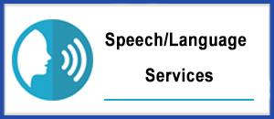

THE DIRECTOR’S CORNER  SPED PROGRAMS AND RELATED SERVICES  Editor—Family Matters Newsletter  Dr. Israel I. Koppisch  iikoppisch@aeetoledo.org  Tel: 419-382-2280 | 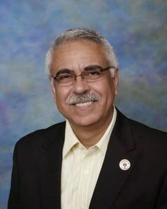
Dear Parents and Friends:

THANKSGIVING PRAYER

Thank you, Lord, for the blessings you have bestowed upon our lives. You have provided us with more than we could ever have imagined. You have surrounded us with people who always look out and bless us every day with kind words and actions. They lift us in ways that keep our eyes focused on you and make our spirit soar.
Also, thank you, Lord, for keeping all our children and staff safe. You protect them from those things that seem to haunt others. You help them make better choices and provide them with advisors that help in life’s difficult decisions. You speak to all of us in so many ways so that we always know you are here for all of us.
And Lord, we are so grateful for keeping those around us safe and loved, especially during this COVID-19 pandemic. I hope that you provide us with the ability and sense to show them every day how much they matter. We hope that you give us the ability to give to them the same kindness that you have provided to all of us at AJHAE… because at our school all family matters.
We are extremely grateful for all of your blessings in our lives. Lord. we pray that you remind us of just how blessed we are and that you will never allow us to forget to show our gratitude in prayer and returned acts of kindness.
May You, our God, bless this Thanksgiving feast
and all of us who shall share it in your holy name.
Thank you, Lord.
Dr. Israel I. Koppisch

DIRECTLY TO YOU…
FROM THE INTERVENTION SPECIALIST
Margaret Hallett

mhallett@aeetoledo.org

Thank you, Father, for having created us and given us to each other in the human family.
Thank you for being with us in all our joys and sorrows, for your comfort in our sadness, your companionship in our loneliness.
Thank you for yesterday, today, tomorrow and
for our whole lives.
Thank you for our friends, for health and for grace.
May we live this and every day conscious of all that has been given to us.
We thank you, Father, for the gift of Jesus your Son who came to our earth and lived in a simple home.
We have a greater appreciation of the value and dignity of the human family because He loved and was loved within its shelter.
Bless us this day; may we grow in love for each other in our family giving thanks to you who are the maker of all human families and our abiding peace.

AMEN.

MY CORNER
MRS. VERNA CHEARS
SPED TEACHER-TUTOR

Here is what the youth of our school is most grateful for:  Myles Wade 6 grade  I'm thankful for my life and family and I guess my friends, my home and school.  DaMya Williams 5th grade  I'm thankful for my friends. I'm also thankful that I have a roof over my head. Also, I have food in my house.  Owen Jones 6 grade  I am thankful for the food because moms puts hard work into Thanksgiving, dinner and I have time to spend with my family.  Deontae Jackson 4th grade  I am most grateful about my school. The School gives us homework and something to do at home. I'm also grateful for my dog "ICE". I get to take him on walks and we play together.  Sharon Humphrey 4th grade  I am most thankful for my family. Also, I am thankful for the School, Police Officers and the Community. |  | Kaijuah Anderson 4th grade  What am I most thankful for, I am most thankful for my mom. She helps me when I make bad choices.  Chrisy Richardson 4th grade  I'm thankful for my mom, because she makes me dinner. She also takes good care of me so I am good. My mom cleans my room up for me, and she lets me go to her room and sleep in her bed.  Nija Tatum 4th grade  What I am thankful for? I am thankful for my best friend Kaijuah because she really cares about me.  Mrs. Chears - Teacher  I am most thankful for each and every one of these notes. So often you forget about those that are in need and don't have some of the luxuries that you and your family have (food, shelter and someone that loves you). We tend to forget about the little things that matter the most. Well I am thankful just to be able to say "Thank you”! I am mostly thankful to God for all that he's done for me. AMEN.

THE SPEECH THERAPIST CORNER  Mrs. LAUREN NOTESTINE  Speech / Language Therapist | A PARENT’S PRAYER  Mrs. ANITA BASS  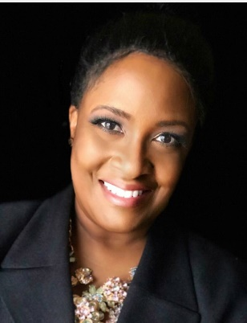
NOVEMBER…A TIME TO GIVE THANKS  As the Speech Language Pathologist for AJHAE,  I am most thankful for the voices of my Speech Students.  Over time, I have seen their voices progress from timid and effortful;  to confident and determined.  My Speech Students often walk into  “Speech Time”  Distracted by the worries of their world.  My Brave, Courageous “Speechies”,  Trust me with their hearts and their voices,  To hear what they cannot say with words (yet!).  During this Month of Giving Thanks,  May your “heart to hearts” with Loved Ones  be blessed.  When a compassionate heart hears what isn’t being spoken,  True communication happens.  Happy Thanksgiving! | Lord, I come to you in my humblest form.  My heart is heavy and sometimes I get tired.  You have called me to be an adoptive grandmother to a precious child who has been through so much.  You've given me this most precious gift and there are not enough words in the world that could describe my love and appreciation.  Today Lord, I need more faith, more hope,  and more truth.  Help me to believe that you are in control and you've prepared a path for our sweet child.  Give me strength, wisdom, and mostly forgiveness  for not trusting you more.  Please revive my tired spirit.  Lord send your army of angels and heal your child’s little developing mind from all traumatic memories, any confusion or feelings of rejection and make this baby whole.  Please cast out anything out of her that is not of you in the name of Jesus. I know your power is great and I believe you are higher than anything she may face in life.  I thank you for each time I get to look into her tiny face and say, "I love you”.  Lord, thank you for the gift of motherhood to the two beautiful girls I gave birth to and raised and for trusting me with this 3rd little soul that you sent into our lives.  In your name I pray,  Amen
-

A SCHOOL LEADER’S PRAYER  Mrs. Sonya Loggins | THANKSGIVING PRAYER  In the eyes of the young ones I see a mirror.  Young minds yearning to know this world.  Small bodies needing nourishment and activity.  Young souls searching for someone to understand and care.  I was once there.  Needing someone to care.  Thankful for the opportunity to dare.  To be one to care,  And share.  To help them learn and grow,  And someday be the ones  Who share and care.  This Thanksgiving, let those of us who have much and those who have little gather at the welcoming table of the Lord.  At this blessed feast, may rich and poor alike remember that we are called to serve one another and to walk together in God’s gracious world.  With thankful hearts, we praise our God who, like a loving parent,  denies us no good thing.  Amen.
A PARENT’S PRAYER  Mrs. Sha’bre Nedd | Lord God, I come to you with head bowed knowing you are good, and revealing in your amazing presence.  Lord, I thank you for the blessing you have given to us in the form of our children. We give them back to you so that you can work in and through them daily. We do not know what great things you have planned for their future, but we are trusting you to keep them and watch over them. We trust you to lead them in the right path of success.  Thank you for trusting us as parents to help nurture and raise these blessing.  Watch over them in this season and keep them safe from all harm.  We are forever grateful in your name we pray, Amen.
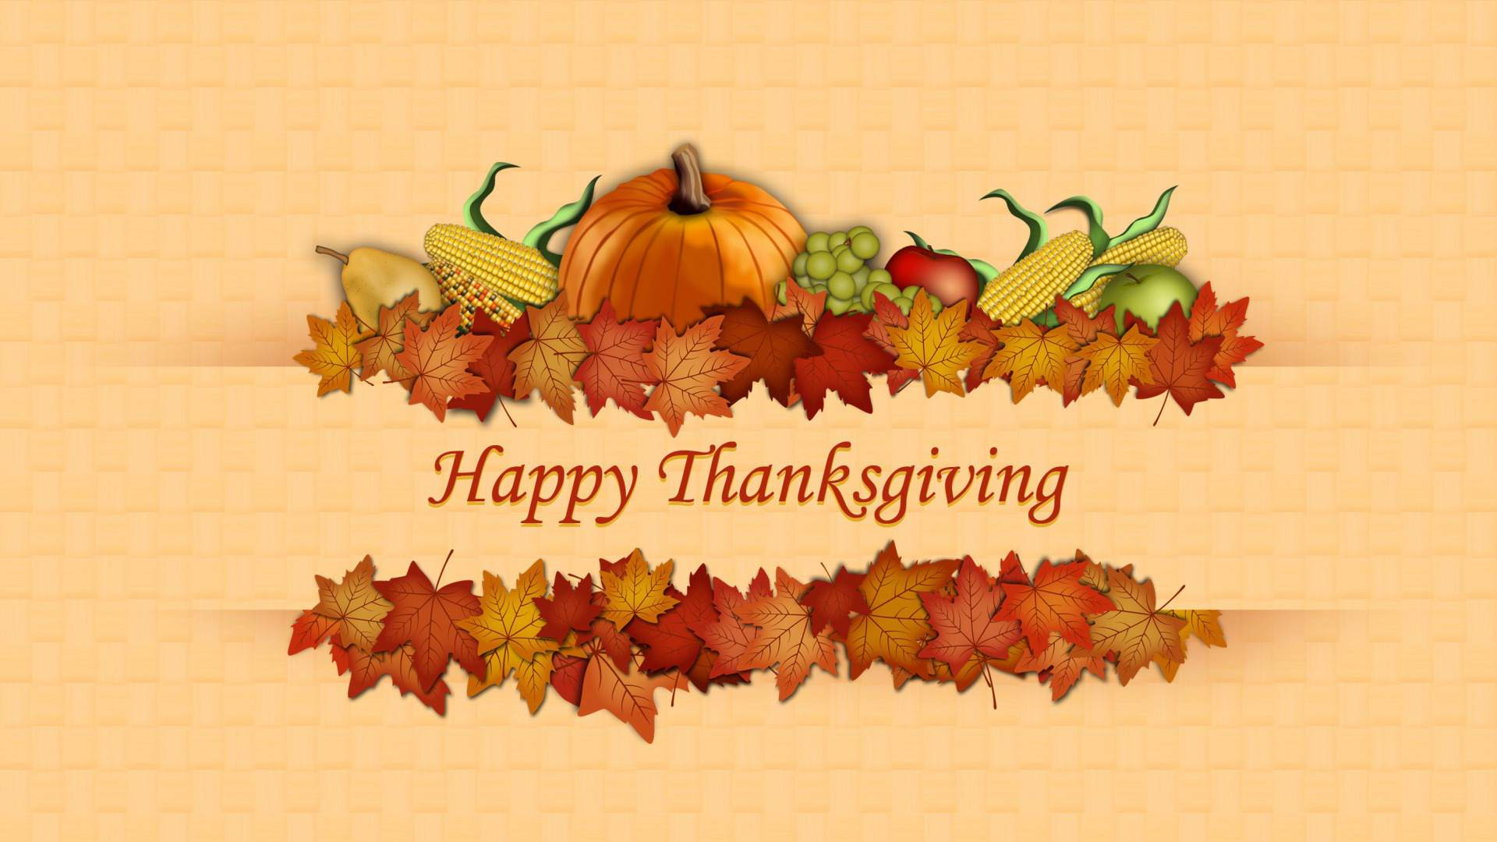
From all the ANN JERKINS-HARRIS ACADEMY OF EXCELLENCE staff members.

A PRAYER FOR OUR TEACHER’S

Thanking Our Educational Heroes in the Spirit of Thanksgiving,
we would like to let our teachers and staff know how thankful we are to have them at AJHAE!
You are all a blessing for our children, our parents and our school.

“Therefore, my beloved brethren, be steadfast, immovable, always abounding in the work of the Lord, knowing that in the Lord your labor is not in vain”. _{1 Corinthians 15:58}

Almighty God.
Grant our teachers and staff members an abundance of Your wisdom.
Prepare their hearts to welcome and love our beloved ones,
And may we make sure to show them love and respect in return.
Give them grace as they help students who aren’t thriving… courage to say what needs to be said…
Tools and knowledge on how and when to speak love, and strength when they feel weak.
When they feel unseen, remind them that no moment goes unnoticed—to You!
They are shaping the future in one small –yet incredible important—ways every day!
We are overwhelmed with gratitude for the gift of learning they share with our school children.

Bless them, Oh Lord, and may they see even just a glimpse of how their faithfulness will forever impact
generations to come.

AMEN.

ANN JERKINS-HARRIS ACADEMY OF EXCELLENCE
Department of Special Services - SPED Programs and Support Staff
FAMILY MATTERS COMMUNITY OUTREACH PROGRAM

Dr. Israel I. Koppisch  Director, Department of Special Services  SPED Program and Related Services  Editor—Family Matters Community Outreach Newsletter  Margaret Hallett  Intervention Specialist  Verna Chears, Teacher-Tutor  Anita Harris- Teacher-Tutor  Hannah Jeffers, Paraprofessional  Deanna Peoples- Support Staff  Chinnon Jaquay, School Psychologist  Lauren Notestine, Speech and Language Therapist  Johnathan Pitts, Occupational Therapist Supervisor  Katelyn Spiess, Occupational Therapist  TBD, Licensed Social Worker / Behavior Specialist  T.A.C.K.L.E. Program Staff- soon to be announced | VISIT OUR NEW WEBSITE  SPED PAGES  www.academyofeducationalexcellence.org

