VISION STATEMENT  At the Ann Jerkins Harris Academy of Excellence, we support and stimulate an educational environment that nurtures the whole child and promotes individuals of excellence.  MISSION STATEMENT  The mission of the AJHAE is to understand the social, emotional, physical and academic needs of our students adopting a whole-child approach.  OUR CORE VALUES  Beliefs and Principles that govern our organizational behavior and support the execution of our educational model.  THE 5 LAMPS THAT GUIDE OUR JOURNEY:  - EXCELLENCE  - RESPECT  - INTEGRITY  - INDIVIDUALITY  - CREATIVITY |  | ANN JERKINS-HARRIS ACADEMY OF EXCELLENCE  728 Parkside Boulevard Toledo, Ohio 43607 |  |  | ANN JERKINS-HARRIS ACADEMY OF EXCELLENCE  - FOUNDED 2012  - A K-7th grade leadership elementary school in Toledo, Ohio  HUMAN RESOURCES DEPARTMENT  EMPLOYMENT INFORMTION  2023-2024

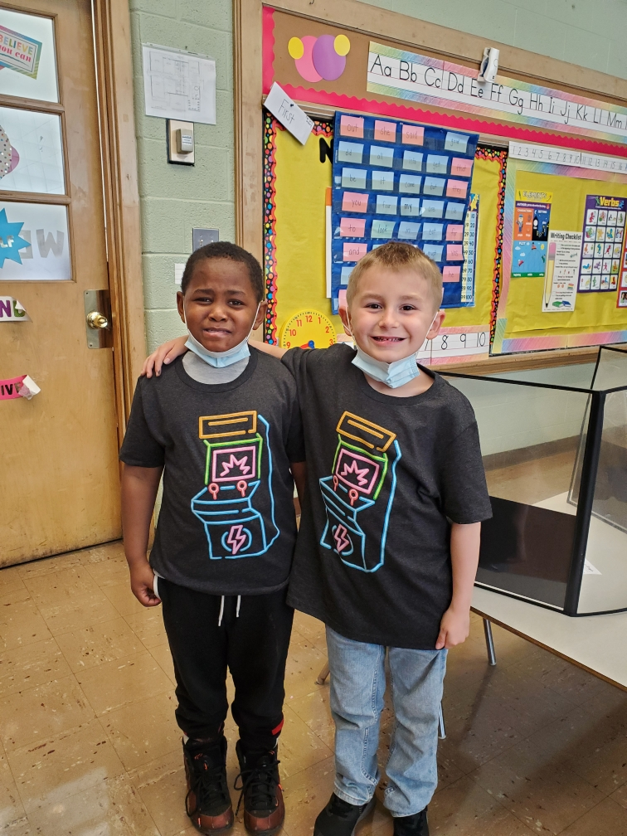  REQUIRED DOCUMENTATION  - EMPLOYMENT APPLICATION (filled in all its areas) (updated residential/mailing address and phone numbers).  - Updated Resume  - Copy of College Transcripts (if applicable)  - Copy of Ohio State Teaching Certification(s)  - Criminal Background Check (FBI AND BCI)  - Copy of Social Security Card  - Copy of Birth Certificate  - Completed W-2 Form  - Completed Payroll Forms  - Copy of Voided Personal Check Account (for Direct Deposit purposes)  HOME OF THE MIGHTY PENGUIN’S | NOTICE OF NON-DISCRIMINATION  THE ANN JERKINS-HARRIS ACADEMY OF EXCELLENCE  DOES NOT DISCRIMINATE ON THE BASIS OF RACE, COLOR, NATIONAL ORIGIN, SEX, DISABILITY, OR AGE  ON ITS STAFF RECRUITMENT, EDUCATIONAL PROGRAMS AND/OR ACTIVITIES.  THE FOLLOWING PERSON HAS BEEN DESIGNATED TO HANDLE INQUIRIES REGARDING NON-DISCRIMINATION POLICIES:  Dr. Israel I. Koppisch  Assistant Superintendent: Human Resources, SPED Program, Regulatory Affairs and Title IX  728 Parkside Boulevard  Toledo, Ohio 43607  Tel: 419-382-2280 X:150  Email: iikoppisch@aeetoledo.org  The ANN JERKINS-HARRIS ACADEMY OF EXCELLENCE is an Equal Opportunity Employer and makes employment decisions based on merit. It is our policy to administer all of our employment practices, including those pertaining to recruitment, hiring, placement, transfer, promotion or compensation (e.g. wage rate), layoff or termination, and selection for training in a nondiscriminatory manner without regard to age, color, gender/sex, national origin, disability, race religion, military or veteran status, genetic information sexual orientation, or on any other basis prohibited by federal, state, or local law. THE SCHOOL will make reasonable accommodation for qualified individuals with known disabilities unless doing so would result in an undue hardship. | DRUG FREE SCHOOL  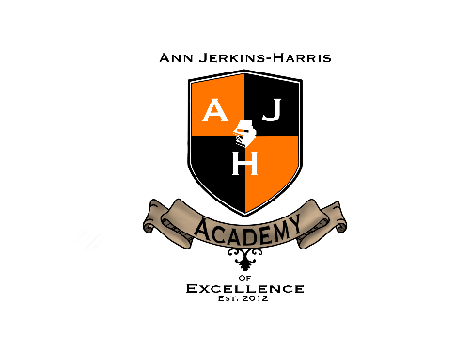  Contact Us  ANN JERKINS-HARRIS ACADEMY OF EXCELLENCE  728 Parkside Boulevard  Toledo, Ohio 43607  419-382-2280 X: 150  Email : iikoppisch@aeetoledo.org  Visit our website and download all employment application forms.  www.ajhae.org  2023-2024 OPENINGS  INSTRUCTIONAL STAFF:  TEACHERS / PARAPROFESSIONALS /  ART TEACHER / TECHNOLOGY TEACHER  BUS DRIVERS / BUS AIDES

