FAMILY MATTERS EVERY CHILD. EVERY PARENT.

ACADEMY OF EDUCATIONAL EXCELLENCE 728 Parkside Boulevard, Toledo, Ohio 43607

A monthly newsletter from the Department of Special Services

VOL. 1 Issue 9 WORKING TOGETHER FOR FAMILY SUCCESS MARCH, 2021
Family Matters is an outreach effort from the Academy of Educational Excellence– Department of Special Services and its SPED Program. Family Matters will provide parents with information about special education and other resources available to assist them to help their children.

Mission Statement
The mission of the Academy of Educational Excellence special educators is to have an active partnership with all school personnel, students and the community. We will nurture individuals, who value themselves and others and provide an educational foundation that enables students to have the ability to think, communicate, create and apply their learning experiences throughout their lifetime.

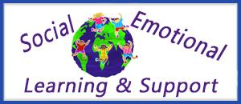
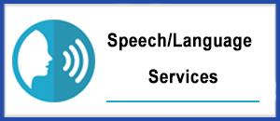
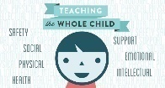

MESSAGE FROM THE DIRECTOR OF SPECIAL SERVICES  Editor—Family Matters Newsletter  Dr. Israel I. Koppisch  iikoppisch@aeetoledo.org  Tel: 419-382-2280 | 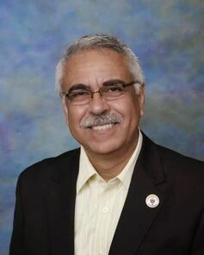
OUR CONDOLENCES
At AEE we all are deeply saddened by the news of Mrs. Ann Harris passing.
(Founder and Superintendent)

Our thoughts and prayers are with her family and especially to all our staff members, students and families who were impacted by her devotion and consecration to education.

May our condolences bring comfort, and may our prayers ease the pain of this loss.
The legacy Mrs. Harris has left on our school family is unmatched by any words that can be written.
Where lives pass, memories carry on forever.

Mrs. Harris soul is now at peace.

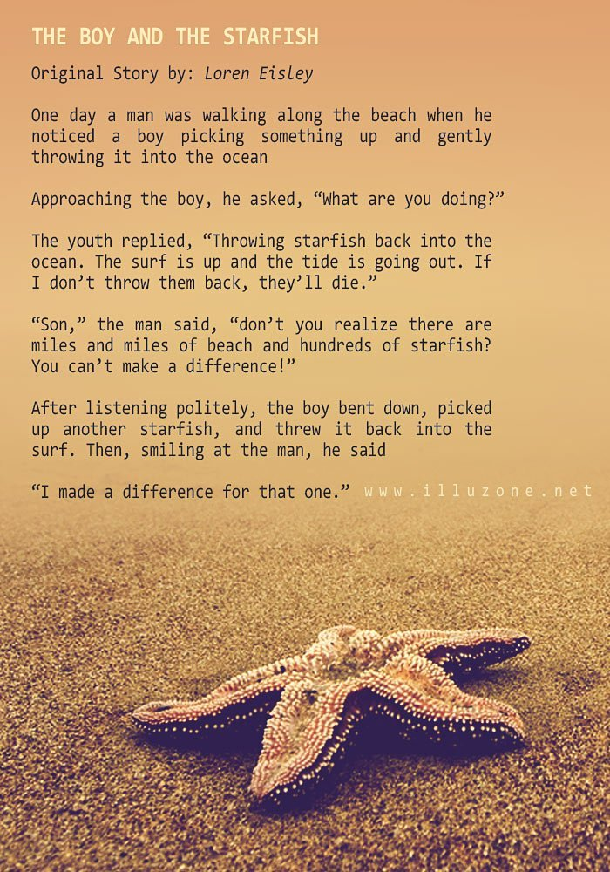
AT AEE SPED DEPARTMENT:
WE WANT TO MAKE THE DIFFERENCE TO ALL OF OUR CHILDREN

Single Parenting During COVID-19

Dealing with a pandemic is hard for any family, but for single parents, it can be extra stressful.

Parenting during COVID-19 isn’t easy. If you’re a single parent, it can be downright overwhelming. “I think there’s probably a lot of anxiety in terms of economic stress and these sorts of things,” shared Zoe Taylor, PhD, developmental family scientist at Purdue University.

A national survey of parents with children under the age of 5 found that single parents with young children are more likely to become unemployed during the pandemic, and nearly twice as many single parents are struggling to pay for food, housing, and utilities. Three times as many single parent’s report difficulty affording childcare. And single parents report higher levels of emotional distress. So, what can you do if you’re running the show on your own? Experts say go back to the basics. Realize you’re in survival mode and focus on making sure your kids eat, sleep well, and exercise every day. Relax screen time rules if it will help you out and try to carve out a little time for yourself.

“Maybe that is having a bubble bath late at night or reaching out to a friend who you haven’t talked to or another single mom potentially where you can feel that you can connect and relate to one another,” said Taylor.

Also remember to be kind to yourself and your kids. This is an uncertain time for everyone. Researchers found that children in single-parent households also report higher overall levels of distress.

AEE SPECIAL SERVICES DEPARTMENT

Physical / Occupational Therapy
SERVICES PROVIDED BY NORTHWEST OHIO SPEECH, LANGUAGE, AND REHABILITATION SERVICES
Ellie Braidic, Occupational Therapist
Beth Wymer, Physical Therapist

The Role of Physical and Occupational Therapists in the School
OT’s and PT’s are considered a related service and are members of the educational team that assist in the development of delayed skills. Therapists provide services with the intent of strengthening the child’s ability to function independently within the school setting, and meet his/her educational goals.

School based therapists provide educationally relevant services in school settings. Therapists are trained to provide many types of developmental and rehabilitative services. However, federal guidelines require the school based therapist to provide only those services that are necessary to enable students to access the educational environment of their school, and to benefit from their special education programs.

Considerations for Eligibility  When deciding the appropriate service delivery for a student, the Evaluation Team must determine the least restrictive environment (LRE).  - Does the challenge significantly interfere with the student’s ability to participate in the special education/general education curriculum?  - Does the challenge in an identified area appear to be caused by limitations in a motor area?  - Can the student’s deficit areas be managed by the educational team without the expertise of an OT or PT?  - Can the student’s deficit areas be managed through classroom accommodations and/or modifications?  - Therapy in relation to other needs. | Service Delivery  Related services may vary over time. Student therapy needs may differ in intensity and in focus during the student’s school years.  - Direct – Therapy techniques are administered by the therapist.  - Consult – is the means by which a therapist can help other professionals meet a student’s IEP. Therapy goals are implemented in the school environment with communication from the therapist typically quarterly to monthly.

ACADEMY OF EDUCATIONAL EXCELLENCE
Department of Special Services - SPED Programs and Support Staff

Dr. Israel I. Koppisch
Director, Department of Special Services
Editor—Family Matters Newsletter

Margaret Hallett
Intervention Specialist

Perris Loggins, Tutor
Hannah Jeffers, Paraprofessional
Heather Dinklage, School Psychologist
Lauren Notestine, Speech and Language Therapist
Ellie Braidic, Occupational Therapist
Beth Wymer, Physical Therapist
Roye Durden, Licensed Social Worker / Behavior Specialist
Jasmin Abu-Hummus, Licensed Social Worker / Behavior Specialist
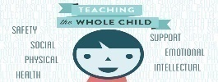

Speech & Language Therapy

SERVICES PROVIDED AT AEE BY NORTHWEST OHIO SPEECH, LANGUAGE AND REHABILITATION
Lauren Notestine, Speech and Language Therapist
What are Speech and Language Impairments?
Speech or language impairments are communication disorders such as stuttering, impaired articulation, language impairment or voice impairment that adversely affects a student's educational performance.

Articulation/Phonology Disorder |  | Language Disorder
I. What is articulation/ phonology?  Articulation is the actions of the organs of speech that modify the breath stream resulting in speech sounds. Phonology is the study of linguistic rules governing the sound system of the language, including speech sounds, speech sound production, and the combination of sounds in meaningful utterances.  II. What are the characteristics of an articulation/ phonology disorder?  Abnormal productions of speech sounds consisting of substitutions of one sound for another, omission of sounds, and/ or sounds distortions.  Phonological processes are patterned modifications of speech sound productions away from the standard adult productions. Phonological processes usually simplify syllable structures or phoneme classes. | I. What is language?  There are 3 areas of language: pragmatics, semantics, and syntax/morphology. Semantics is the study of words and the meaning of words. Examples are concepts, object function, categories, etc. Pragmatics is the practical application of language; the ability to comprehend language and communicate with others. Syntax is the application of grammatical rules in language. Examples are pronouns, word order, sentence structure, etc. Morphology is the study of the smallest units of meaning in a language, for example the plural [s], and how these units affect word meaning.  II. What are the characteristics of a language disorder/ delay?  Children who do not develop language shills appropriately are language delayed or disordered. Causes for a language delay/ disorder include: hearing impairment, cognitive impairments, autism, physical handicap that prevents the child from interacting with their environment, and lack of stimulation. Often, there is no identifiable cause for language disorder.  Children can have receptive language impairments, expressive language impairments or both. Language disorders are changeable; at different stages of development children have different demands on their language systems. Receptive language impairments mean that a child has difficulty understanding language. They may have limited vocabulary. They may not understand the meaning of word endings: that adding "s" makes a noun plural, or "s" indicates possession, or that an "ed" ending on a verb means that the action is past. They may have difficulty understanding nonverbal signals, like body language. They may not understand sarcasm, or indirect requests (e.g., "it's cold in here" can mean please close the window").  Expressive language impairments show up in how a child speaks. They may use only a few words in each sentence. They may leave off word endings, or the little words like "is" and "are". They may not know the names of many words. They may not always use language appropriately and appear to be rude by being too direct or blunt. They might not consider their partner's needs, using ambiguous referents (lots of "he", "she" and "it" when the subject has not been clearly identified), or changing topics abruptly.  Remember that receptive language is usually slightly ahead of expressive language. If a child is speaking in 2 word utterances, he/she is probably able to fully understand 3 word utterances.

Fluency Disorder  I. What is fluency?  Fluency is the flow of speech. Fluent speech is smooth, forward-moving, unhesitant and effortless speech. A "dysfluency" is any break in fluent speech. Everyone has dysfluencies from time to time. "Stuttering" is speech that has more dysfluencies than is considered average.  Everyone has dysfluencies in their speech. The average person will have between 7-10% of their speech dysfluent. These dysfluencies are usually word or phrase repetitions, fillers (urn, ah) or interjections. When a speaker experiences dysfluencies at a rate greater than 10% they may be stuttering. Stuttering is often accompanied by tension and anxiety. The types of dysfluencies in stuttering may also be different. Sound or syllable repetitions, silent "blocks", prolongations (unnatural stretching out of a sound) and facial grimaces or tics can be present.  Many children go through a period of normal non-fluency between the ages of 2 and 5 years of age. The frequency of dysfluency can be greater than 10%. The dysfluencies are usually whole word or phrase repetitions and interjections. The word is repeated just once or twice and is repeated easily. The child does not demonstrate any tension in their speech and is often unaware of their difficulty. It has been suggested that the cause of this non-fluency may be a combination of increases in language development, development of speech motor control, or environmental stresses that can occur in typical busy families. Some children "outgrow" these dysfluencies, others do not. | DID YOU KNOW......?  - Over three million Americans stutter  - Stuttering affects four times as many males as females  - People who stutter are as intelligent and well-adjusted as non-stutterers  - Despite decades of research, there are no clear -cut answers to the uses of stuttering, but much has been learned about factors which contribute to stuttering.  - There are no instant miracle cures for stuttering. Therapy is not an overnight process.  - Here are some famous people who stutter(ed):  - Moses, Aesop, King George VI, Isaac Newton, Charles Darwin, Clara Barton, Lewis Carroll, Marilyn Monroe, Jimmy Stewart, Mel Tillis, Anthony Quinn, Winston Churchill, James Earl Jones, Ben Johnson, Bruce Willis, Greg Luganis, John Up dike, Carly Simon, Bo Jackson, Bill. Walton, Bob Love.  - President Joe Biden
Voice Disorder | I. What is a voice disorder?  A voice disorder may be characterized by an abnormality in the student's vocal quality, pitch, loudness, resonance, or duration. The child's voice does not sound "right". Often vocal nodules are present.  II. What qualifies your child for voice therapy?  A student will be considered for voice therapy upon the recommendation of a physician if he/she displays a voice that is abnormal for his/her chronological age, sex, and size.

BEHAVIOR INTERVENTIONS
PROVIDED AT AEE BY CAREGIVER GROVE
BEHAVIORAL- HEALTH AND DISABILITIES SERVICES

Roye Durden- Licensed Social Worker and Behavior Specialist
Jasmine Abu-Hummus- Licensed Social Worker and Behavior Specialist

Caregiver Grove is committed to providing responsive and innovative services to children, adolescents, and adults. We specialize in working with the behavioral health, among a diversity of other services. We recognize that every client is different. That's why we don't work from a standard treatment plan. After carefully examining their needs, we develop a highly personalized treatment plan to address their unique needs.

We are committed to enhancing the behavioral health and wellness of individuals, families, and communities through our vision:
​
- The promotion of behavioral health and wellness, prevention, early intervention, treatment, and recovery.
- The creation and leadership of an integrated network of providers that promotes universal access to comprehensive, data-driven services.
- Advocacy and leadership of behavioral health-related efforts to align resources, programs, and policies.

PSYCHOLOGICAL ASSESSMENTS
SERVICES PROVIDED AT AEE BY TOTAL EDUCATION SOLUTIONS
Heather Dinklage, School Psychologist
Assessments are individually tailored to answer a question or questions about each child, such as, diagnostic questions, questions about the child’s pattern of skill strengths and weaknesses and how those might help to explain the difficulties the child is having, questions about whether the child is behaving in ways that are normal vs. abnormal for their age, and also questions about the reasons/function of the child’s behavior.
A full psychological evaluation typically includes an in-depth clinical interview in addition to tests of ability/intelligence, academic achievement tests, development, and/or social/emotional concerns. Specific diagnostic assessments including the Autism Diagnostic Observation Schedule-II (ADOS-II) may also be used.
TES staff work closely with the IEP team to assess and make recommendations based on a battery of tests carefully chosen to meet the specific needs of each student. Additionally, the psychologists at TES specialize in providing comprehensive Independent Educational Evaluation (IEEs) that help both the school and family better understand and address the needs of the students.

